**Model Development Phase**

|  |  |
| --- | --- |
| Date | 15 March 2024 |
| Team ID | LTVIP2024TMID24892 |
| Project Title | Liver Patient Identification – prediction of liver patient |
| Maximum Marks | 4 Marks |

**Initial Model Training Code, Model Validation and Evaluation Report**

The initial model training code will be showcased in this. The model validation and evaluation report will include classification reports, accuracy, and confusion matrices for multiple models, presented through respective screenshots.

**Initial Model Training Code:**

**Train Test split for all models:**

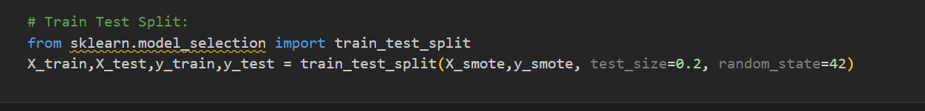

**Random forest model:**

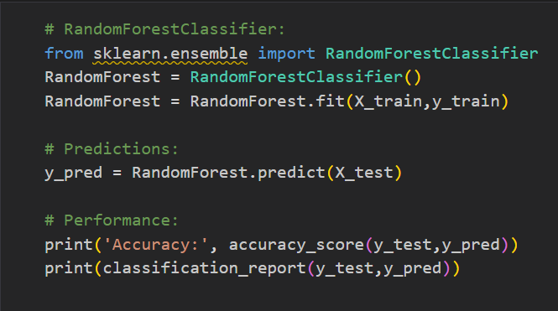

**KNN Model:**

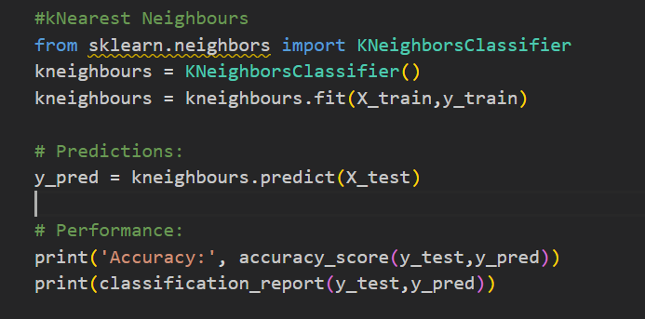

**Support vector Machine Model:**



**Model Validation and Evaluation Report:**

|  |  |  |  |
| --- | --- | --- | --- |
| **Model** | **Classification Report** | **Accuracy** | **Confusion Matrix** |
| Random Forest |  | 82% |  |
| Support Vector Machine |  | 75% |  |
| KNN |  | 67% |  |